Reflect & Assist

Kacey Morris

CST-451 Capstone Project Final Architecture & Design

Grand Canyon University

Instructor: Professor Mark Reha

Revision: 2.0

Date: April 24, 2022

**ABSTRACT**

The Reflect & Assist is a Raspberry Pi kit with all materials and software included to create a Smart Mirror display. This display is a mobile mirror that projects information contained in modules alongside its reflection. The Reflect & Assist kit will include the Raspberry Pi, a monitor, reflective acrylic, links to required GitHub modules, as well as instructions on how to set up the Raspberry Pi, install all required dependencies, and assemble the mirror set up. As a kit, those interesting in building a customizable smart mirror will find all essential resources in a centralized location, making learning programming and embedded systems simpler and more accessible.

The kit will include 14 different display module options including an alarm clock, weather display, a daily Bible quote, and many others, as well as access to a website for managing the individual display and information preferences. To encourage creativity and expansion, access to an extended list of potential modules and a template for personalized module creation will be included as well.

|  |
| --- |
| History and Signoff Sheet |

**Change Record**

|  |  |  |
| --- | --- | --- |
| **Date** | **Author** | **Revision Notes** |
| 11/21/2021 | Kacey Morris | Initial draft for review/discussion |
| 4/23/2022 | Kacey Morris | Removed pseudocode, replaced diagrams with more detailed diagrams, technical preferences updated, updated ER diagrams to include preferences |

|  |
| --- |
| **Overall Instructor Feedback/Comments** |

|  |
| --- |
| **Overall Instructor Feedback/Comments** |

**Integrated Instructor Feedback into Project Documentation**

☒ Yes ☐ No

**TABLE OF CONTENTS**

Design Overview 4

Detailed High-Level Solution Design 5

Detailed Technical Design 6

Appendix A – Technical Issue and Risk Log 7

Appendix B – References 8

Appendix C – External Resources 9

Design Introduction

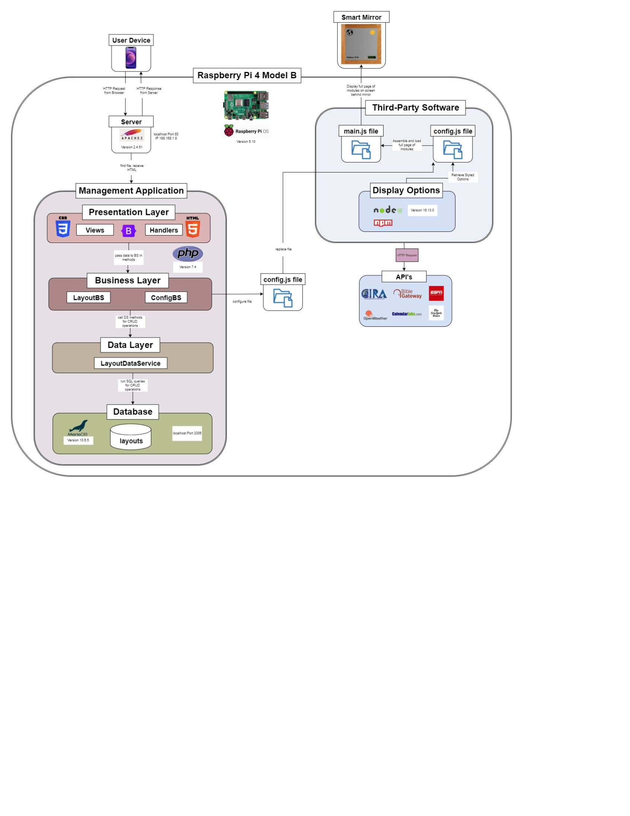

*High-level design diagram showing the N-Layer design, technologies, and integration with third-party applications.*

The high-level design details the general interactions between the application components, as well as the technologies that will be utilized within each for functionality. This application is an integration project with three types of components including the main third-party mirror application, external third-party display options, and the management GUI site. All application files will be stored and locally hosted on the Raspberry Pi 4 Model B. The third-party mirror display software and third-party mirror display options access API services and configure the final display using NodeJS and NPM to run JavaScript. Currently, the third-party smart mirror display can only be manipulated through altering the code directly, indicating the need for a Graphical User Interface that is met through the development of the management site. This will include an N-Layer PHP application that retrieves user input, manipulates a MariaDB database, and configures the third-party application without the need of manual code alterations. To achieve this goal, the management application will create a new config file based on database information and user input, and replace the existing config file in the main third-party application.

|  |  |  |  |  |  |
| --- | --- | --- | --- | --- | --- |
| Deliverable Acceptance Log | | | | | |
| ID | Deliverable Description | Comments | Evaluator (internal or external as applicable) | Status | Date of Decision |
| 1 | Data Dictionary | This file contains rationale for the database associated with the management application and each table and column. | External | Completed | 11/21 |
| 2 | Design.io | This contains all designs created in draw.io, organized into tabs. If the images included in this document are too small, please reference this file. | External | Completed | 11/21 |
| 3 | DDL Script | These scripts establish a database with a single layouts table. The table columns match the properties of the design layout class. | External | Completed | 11/21 |
| 4 | Design.io Image Files | This contains all designs created in draw.io as PNG files to ensure all diagrams can be read clearly. | External | Completed | 11/21 |

Detailed High-Level Solution Design

|  |  |  |
| --- | --- | --- |
| Proof of Concepts | |  |
| **Description** | **Rationale** | **Results** |
| 1 – All third-party applications have been downloaded on the Raspberry Pi. | This confirms that the third-party application that displays the mirror information can be integrated together within the configuration file. It is essential to make sure the existing software is not outdated and still functional. | The third-party applications integrate with each other. |
| 2 – All third-party displays have been configured to display on an external monitor. | Testing this functionality ensures the proper format is established for displaying information, and that the mirror will display information. | Information from each display option has been displayed appropriately on the monitor. |
| 3 – A simple PHP application with a MariaDB connection has been created and hosted on Apache2. | As a basis for the PHP application, the proper technologies need to be tested to ensure they will run on the Pi, connect, and can be accessed. | The application runs on the server and can write to a database using SQL queries. |
| 4 – The PHP application and third-party applications were run at the same time. | This test is to prove the applications run on different ports and can be hosted from the Pi at the same time. | Both applications were run locally and accessible on different ports. |
| 5 – A test text file was written by the PHP application to a test folder in the third-party application. | In order to integrate the management application with the third-party software, the PHP application must be able to write to the file location where the third-party app is located. Ensuring a test text file can be written to the external location sets the precedent that the config file can also be integrated. | The PHP application can write to a location outside the original application. |

|  |
| --- |
| Hardware and Software Technologies |
| 1 – Raspberry Pi 4 Model B |
| 2 - Raspberry Pi OS (AKA Raspbian) v5.10 |
| 3 - Apache2 v2.4.51 |
| 4 - PHP v7.4 |
| 5 - Geany IDE v1.33 |
| 6 – MariaDB v10.6.5 |
| 7 – phpMyAdmin v5.1.1 |
| 8 – NodeJS v16.13.0 |

|  |
| --- |
| Third-Party Software |
| 1 – Smart Mirror Application - MichMich/MagicMirror from GitHub |
| 2 – Moon Phases Display Option - Nolankingdon/MMM-moonphase from GitHub |
| 3 – Daily Bible Verse Display - Arthurgarzajr/MMM-dailybibleverse from GitHub |
| 4 – Globe Display Option - Lukeskywalker92/MMM-globe from GitHub |
| 5 – Insults Display Option - Mykle1/MMM-Insults from GitHub |
| 6 – Alarm Clock Display Option - Fewieden/MMM-AlarmClock from GitHub |
| 7 – Sports Stats Display Option - JCLARKE0000/MMM-myscoreboard from GitHub |

**Logical Solution Design:**

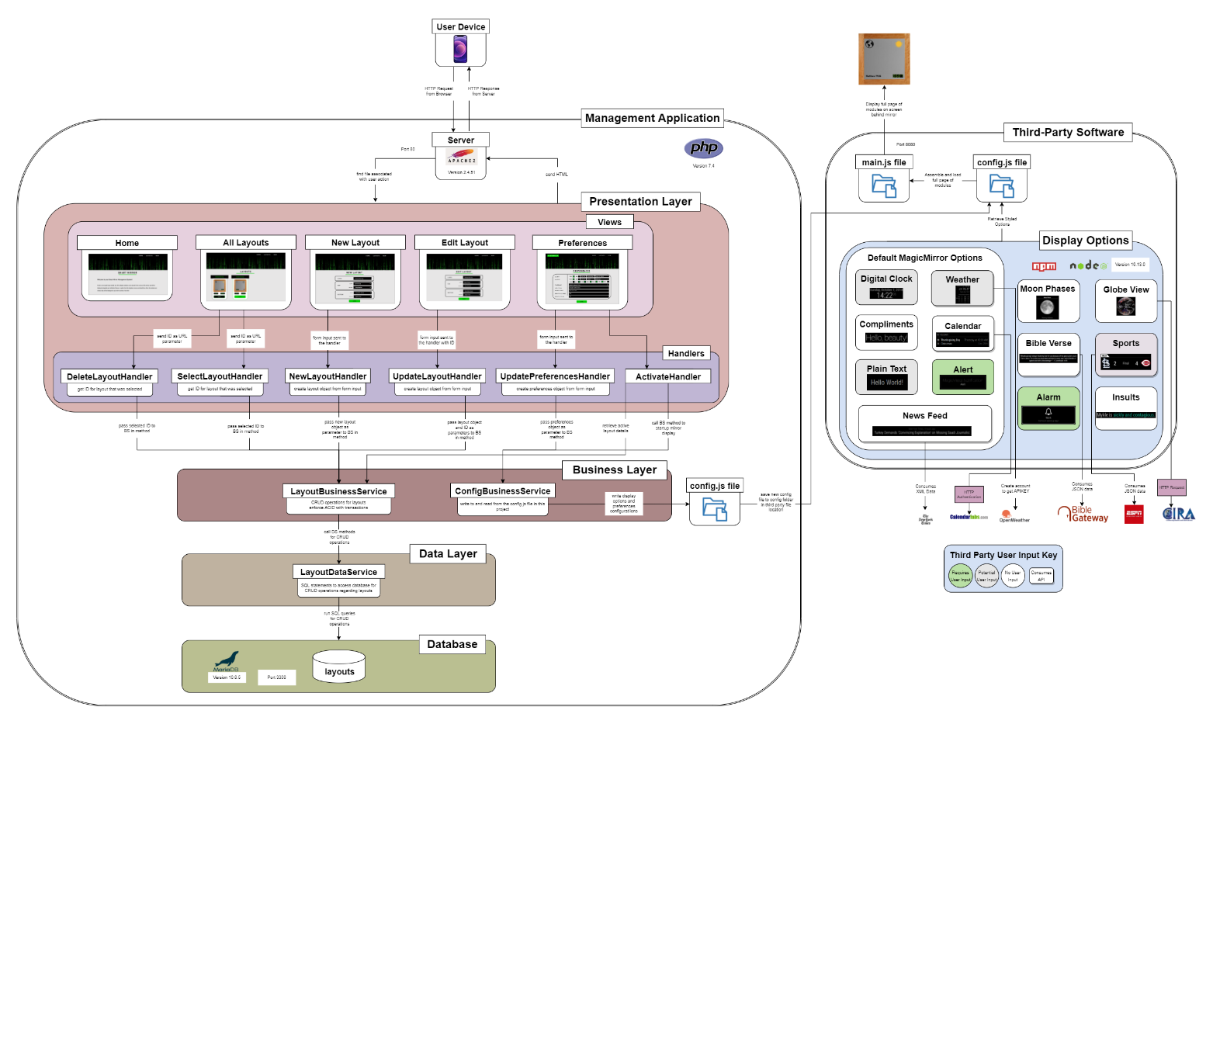

*This is the logical solution block diagram which details the layout of the applications. It includes all technology utilized within the design, interface designs, actions, and interactions between components of the system. For a more detailed description, reference the* ***General Technical Approach*** *section below.*

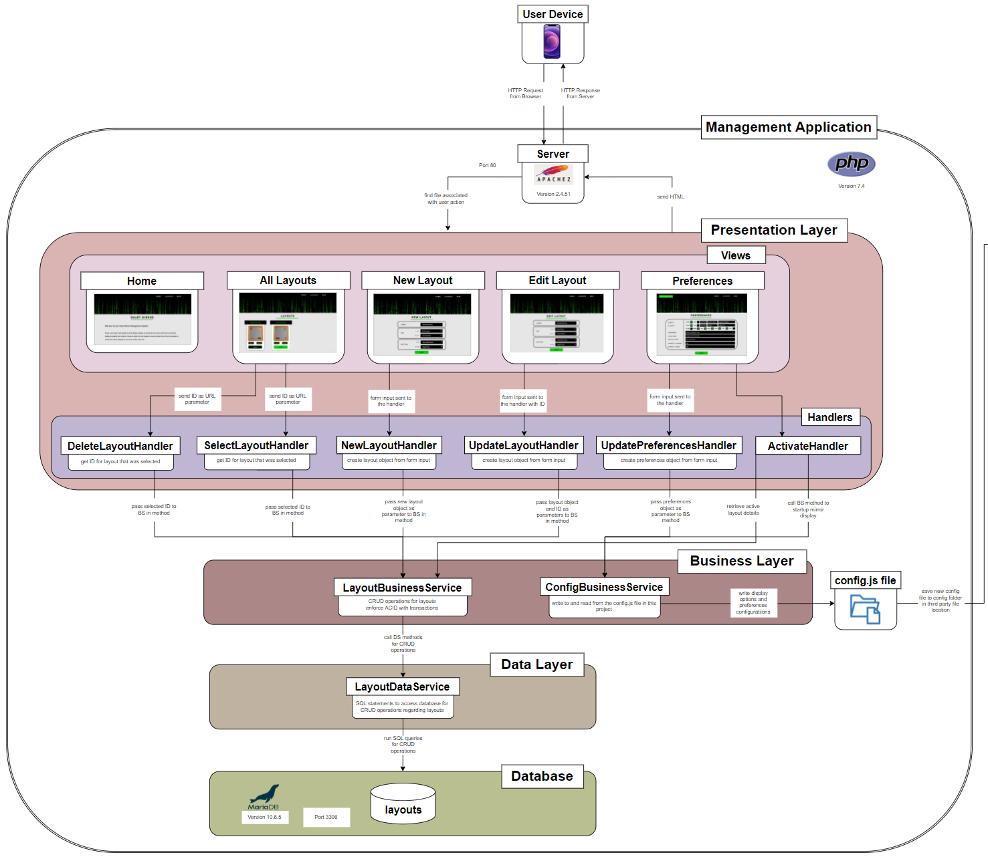

*Image of the management application logical diagram separately for better viewing.*

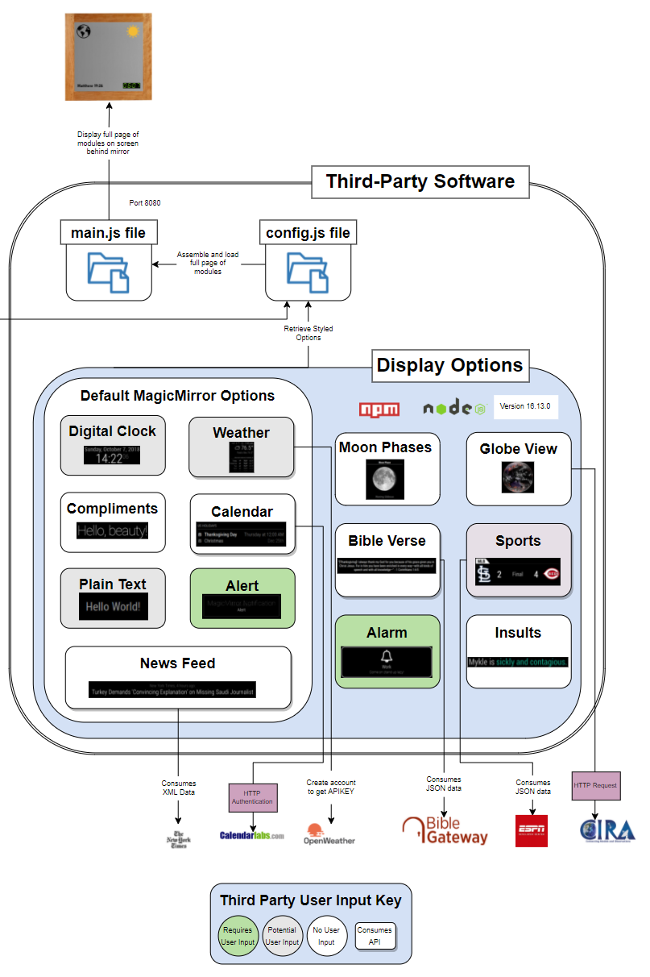

*Image of the third-party logical diagram separately for better viewing. These images can also be found in the external documents zipped file.*

**Physical Solution Design:**

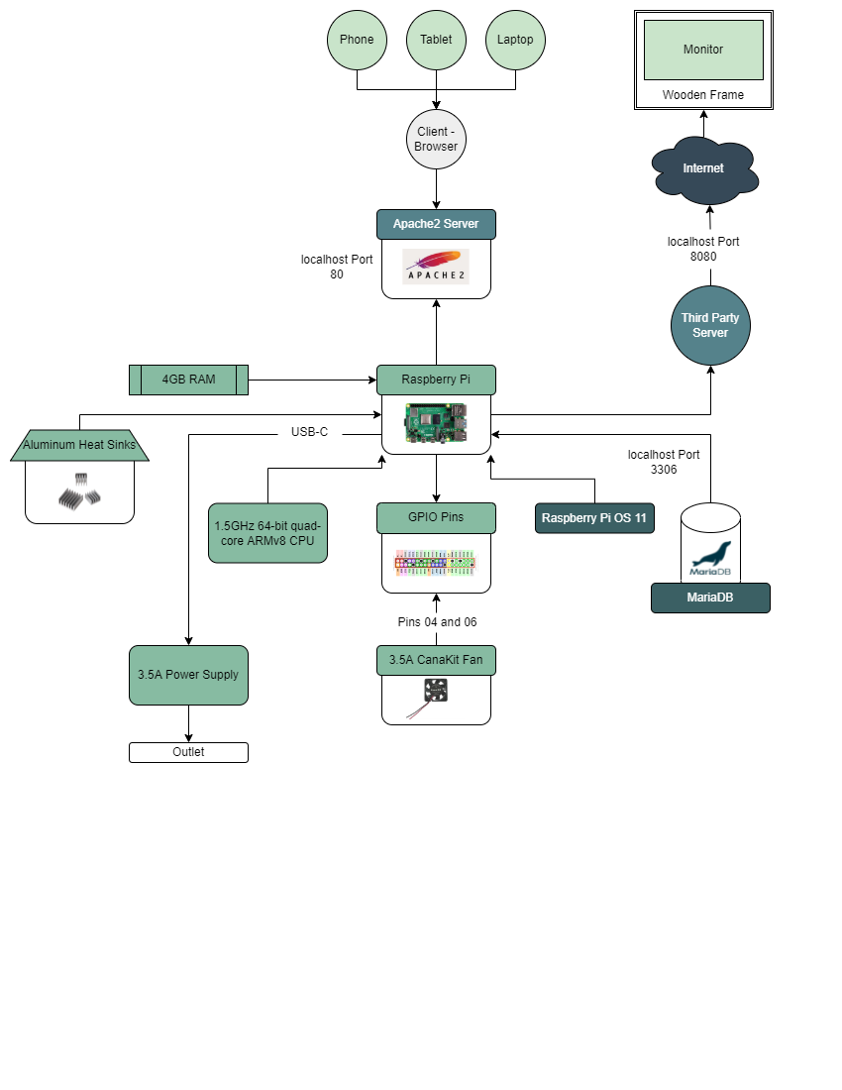

*The physical solution diagram details the physical components within the system and their configurations. All applications are stored on the Raspberry Pi and will be hosted locally for displays.*

Detailed Technical Design

**General Technical Approach:**

The main focus of this application is placed in the management website, as the third-party applications have already been developed. With this application, the user will be able to perform CRUD operations on layout designs through a graphical user interface. When they first navigate to the site, they will land on the home page. All pages within the application will follow a similar layout defined in an external CSS file to maintain a cohesive look throughout the website. The home page will include an introduction to the site and its purpose as well as the main navigation links at the top of the page. These links will direct to the view all layouts, create new layout, and preferences pages, as well as a link for the home page. If the user selects the view all layouts page, they will be displayed all layouts that have been previously configured. The user will have the option to edit or delete any of the layouts, or select a layout to be displayed on the mirror when it is turned on next, which will be controlled through the layout business service. In the create new layout page, users will be able to label a new layout and select from a list the display options they would like included in each corner of their mirror display. When they save the new layout, they will be directed back to the all-layouts page with their new layout displayed with the other options. From the all-layouts page, the edit layout page can be accessed with a button associated with each layout. The edit and delete buttons function similarly to that of adding a new layout, where the user is then returned back to the all-layouts page with the updated all layouts list. The preferences page works similarly where the user can edit information in the form, save their edits, and is then redirected to the layouts page. This page also has functionality to apply the changes made in the management site to the physical mirror display, which is done by replacing the config file in the third-party application by one generated in the management app. The third-party application and management site must be integrated together through the configuration file. This new config file generated will mimic the original but with the selected layouts and their desired locations indicated within the generated file.

The management site will follow N-Layer design architecture with views and handlers in the presentation layer, business services for layouts and preferences in the business layer, data access objects for layouts in the data layer, and a MariaDB relational database in the database layer. In the presentation layer, views will display HTML pages styled with CSS utilizing PHP to display content. Actions within the views will link to handlers written in PHP that will create a business service object to perform the desired operation. After the operation has been completed, the user and resulting data will be redirected to another view. The business layer will contain business service classes for the layouts and preferences functions. Because the layouts are saved in a database, the layouts business service will create a data service object and call the manipulation methods defined there. In the data service layer, methods will connect to the database and query the MariaDB database with SQL statements to manipulate the layouts table.

The preferences business service works similarly, updating a row in the database table that is associated with the currently logged in user. When the button is selected to update the mirror display, if any of the selected display options require user input, such as the time zone of the user for the clock display, this preferences table will be accessed and incorporated in the creation of the configuration file. Once the selected layouts are formatted correctly in the configuration file, the config file in the third-party application will be overwritten and the mirror display options will be updated.

**Key Technical Design Decisions:**

The third-party applications are written in JavaScript using NodeJS and NPM. Because they are already developed and this project focuses on integration, the creation of the management site will have no influence on these technologies.

The management site will be developed using HTML, Bootstrap, and custom CSS for frontend display and PHP for backend. PHP uses a super global variable $_POST to access form input data which can then be used in PHP methods to manipulate that data. This language was chosen for the ease in which websites can be created and served, as well as the database integration functionality. MariaDB will be used for database needs because it is a relational database that can be manipulated using SQL queries, and can be hosted on the Raspberry Pi 4 Model B. PhpMyAdmin will also be used to provide a graphical interface for interactions with the database. Apache2 will be used to host the management site because it integrates well with the Raspberry Pi and will allow the user to access the site. To develop the application, the Geany IDE will be utilized because it is lightweight and supports PHP. It is also already downloaded on the Raspberry Pi OS, which was selected for its compatibility with the hardware.

To support the design, a set of proof of concepts were executed as follows. All the third-party applications were downloaded on the Raspberry Pi following the instructions located on each GitHub page, all of which are linked in the **References** section. By downloading the applications and reviewing the configuration formatting required for each option, it is confirmed that the third-party applications are formatted in a similar fashion and can be integrated together. The configurations were also all tested to display on the mirror surface. This test is essential when confirming that the third-party applications are current and functional, while also providing important information about the formatting and means of accessing information. To test concepts regarding the management site, a simple PHP application was developed in the Geany IDE that connects to a MariaDB and is hosted locally with Apache2. When running this application, it is proven that a PHP application can be developed on the Raspberry Pi using these technologies, and sets the base set up for the management application. The simple PHP application and third-party software were also run at the same time to ensure they could function properly while served locally on separate ports. Finally, a test text file was written by the simple PHP application to a test folder in the third-party application to ensure they could be successfully integrated together. This test sets the precedent that, when developed, the management application will be able to write a new configuration file and access the file system location of the third-party application. In order to apply the selections made by the user, this concept is essential.

**Database ER Diagram:**

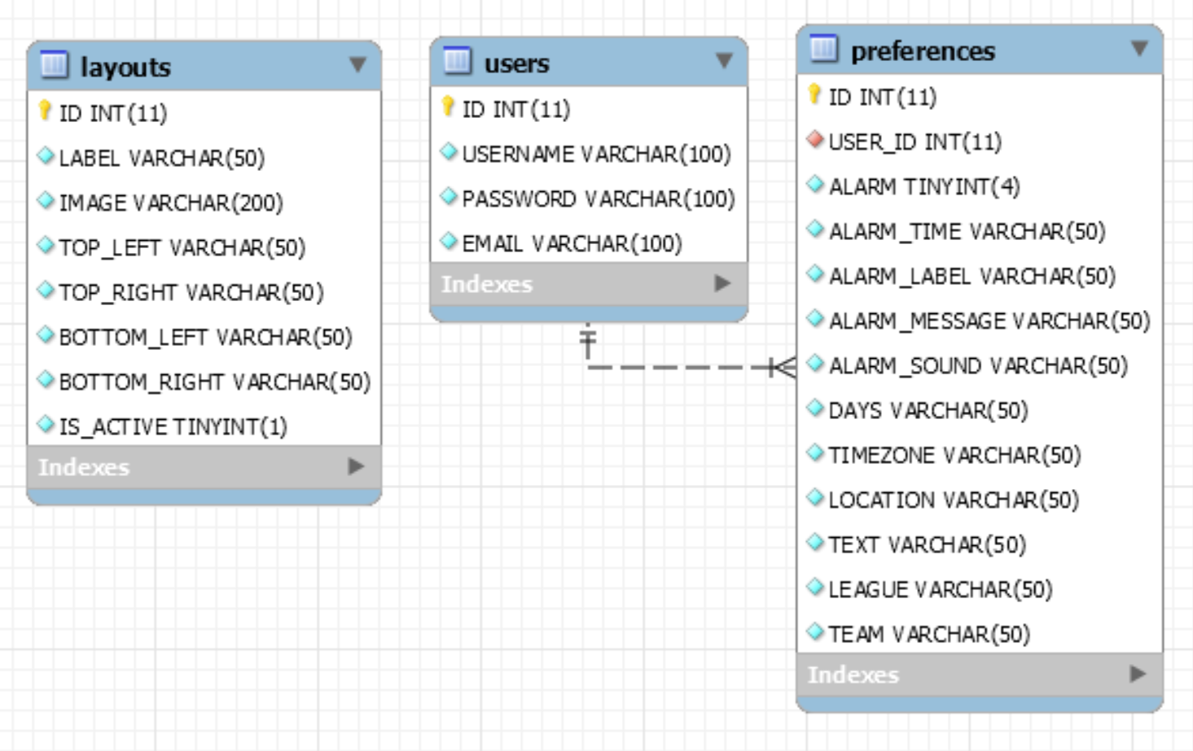

*This is the structure of the mirror database in MariaDB for this project. The ID will be an auto-incremented primary key for the table for all tables, and the users and preferences table are related, where the user has an entry in the preferences table, associating the two tables.*

**Database DDL Scripts:**

As indicated by the Deliverable Acceptance Log, the DDL scripts will be submitted as an external addition. When run, they will establish a relational database with a single layouts table. This can also be found in the GitHub repository.

**Flow Charts:**

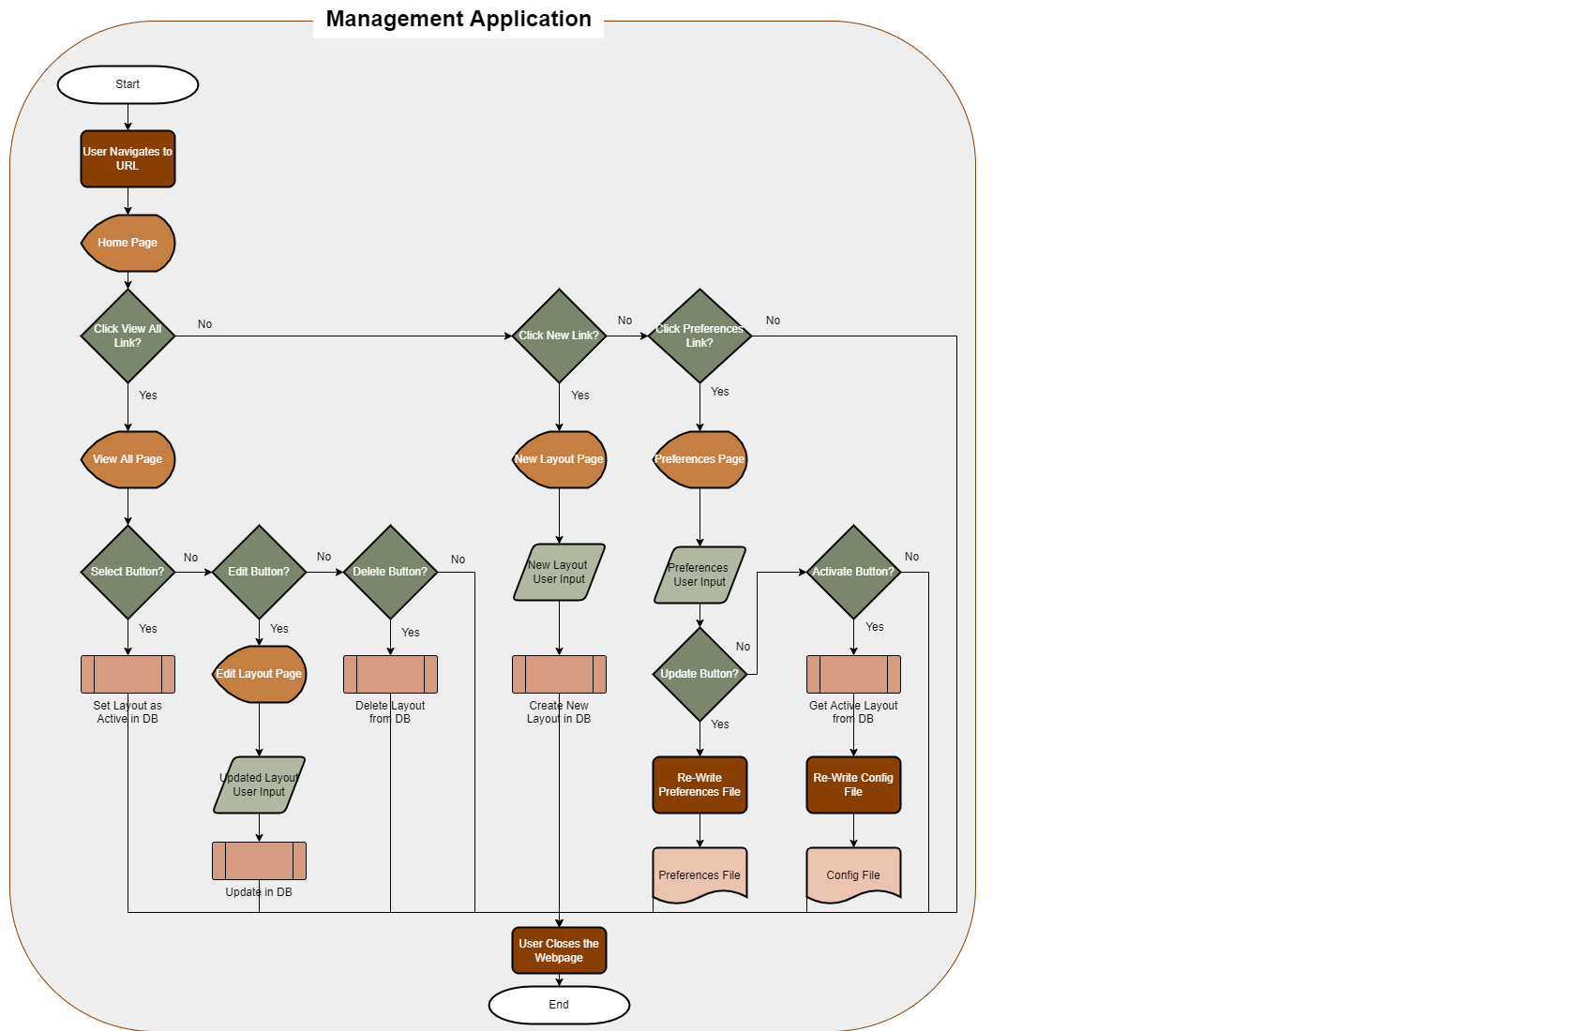

*The flowchart for the management application outlines the workflows associated with user input and site interaction. Predefined processes follow a similar process of passing information down layers, and interacting with the database.*

**Sitemap Diagram:**

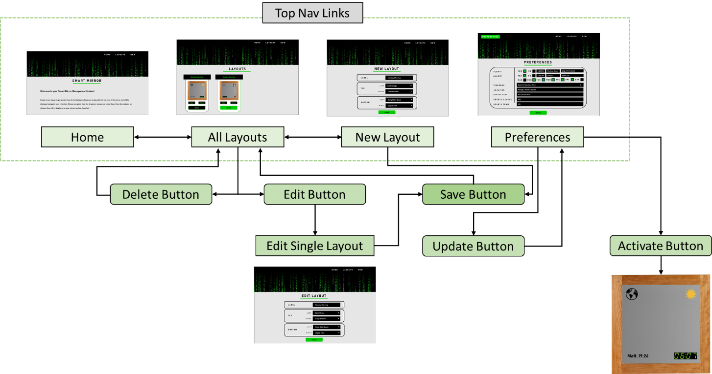

*Sitemap diagram detailing the interactions between each page through link and button clicks.*

**User Interface Diagrams:**

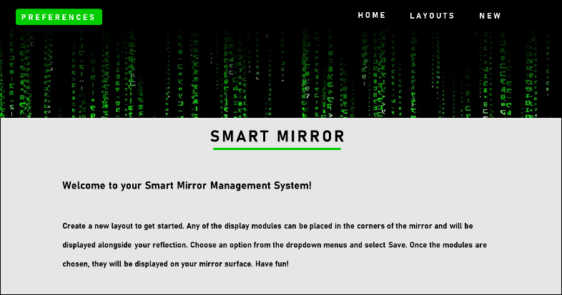

*The proposed home page layout and content for the management application.*

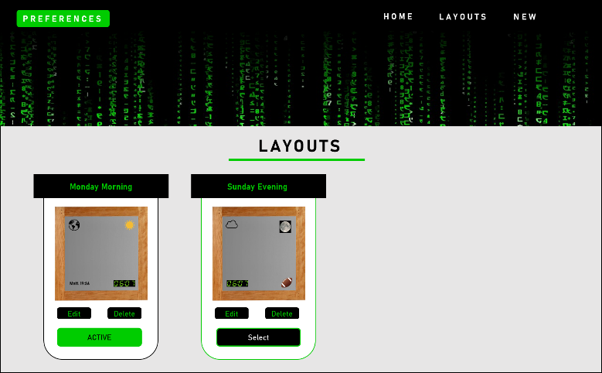

*The user interface design for the all-layouts page, with one layout selected as a display.*

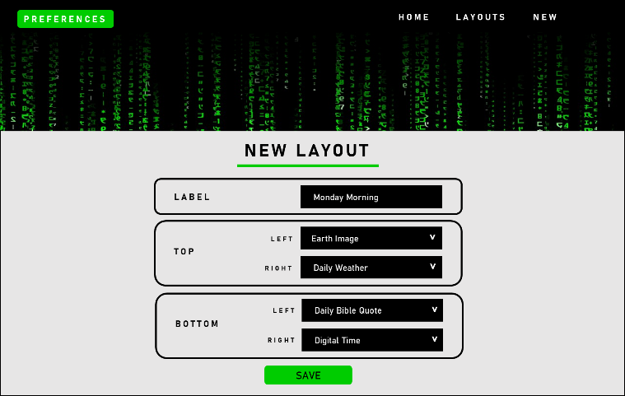

*The user interface design for the new layout page.*

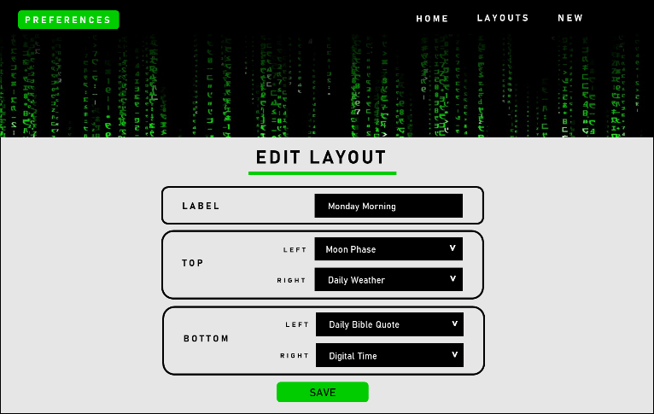

*The user interface design for the edit single layout page.*

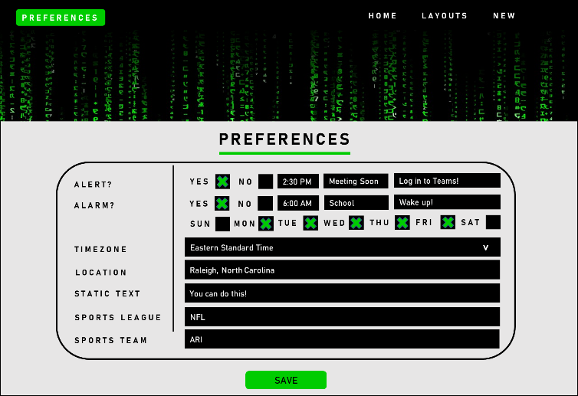

*The user interface design for the specifying preferences page.*

**UML Diagrams:**

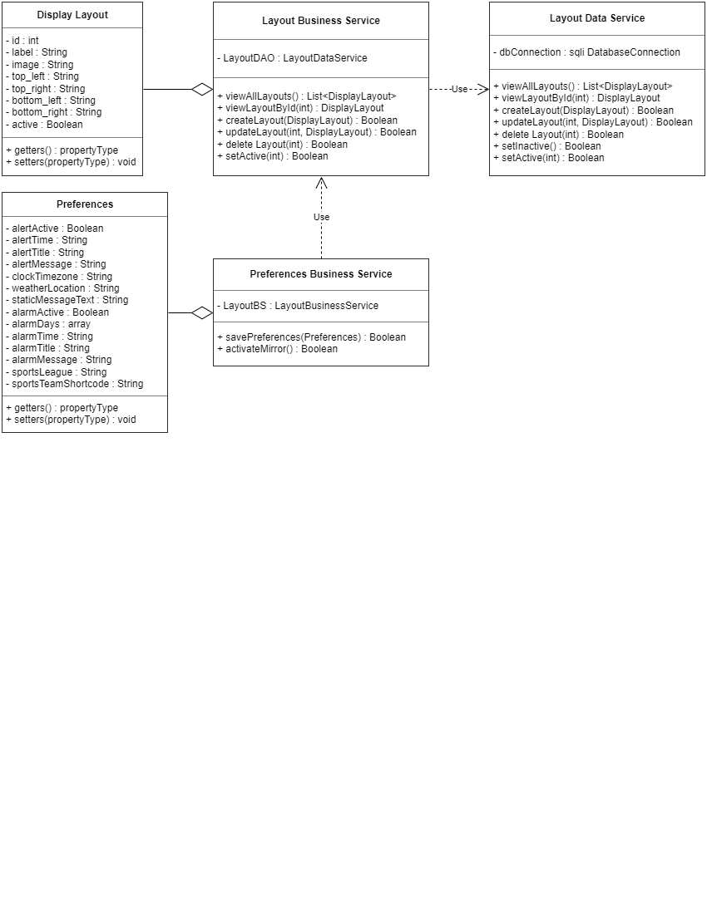

*Within the management system, these classes will be defined within the application. The Business Services will use the Layout and Preferences classes to manipulate persistent data. The Preferences Business Service will use the Layout Business Service for accessing displays, and the Layout Business Service will use the Data Service to save information to a database.*

**Service API Design:**

The management application will not consume or publish any API information. The third-party application, however, will communicate with several applications to consume JSON data relating to display options. Specifically, the news feed display consumes JSON data concerning news headlines from the New York Times API, using an API key included with the third-party application. Accessing and consuming data for the weather application also requires an API key which can be obtained by creating an account with Open Weather. The user’s location will be retrieved through the preferences form in the management site but will be set as a default of Phoenix, Arizona to ensure the display works regardless of whether the user submitted a preference. To fill the calendar with US Holiday dates, the third-party application uses HTTP Authentication to consume data from the Calendar Labs ical API. Bible Gateway provides open-source API containing information concerning a Bible quote that is updated daily and can be accessed through a simple HTTP request. ESPN also provides an open-source API concerning data about active sports games that can be accessed through an HTTP request. Preferences about what game statistics the user would like to view can be configured through the management site as well, and again default values are set to ensure the application can still run without user preferences. The defaults are set to statistics about the Arizona Cardinals in the NFL. Cooperative Institute for Research in the Atmosphere, or CIRA, is used for the globe display option. This company provides an URL with an image of the globe that updates every ten minutes. The URL is then utilized within the third-party application. All API information is consumed and formatted by the third-party application using JavaScript.

**NFR’s:**

Non-Functional Requirements included in the project include extensibility, durability, and emotional factors. To ensure extensibility, the project must be compatible with additional display options. This can be tested through the addition of the non-default display modules, and the user’s ability to access and incorporate them into the mirror display. The addition of the six external third-party display options should be accessible through the management site which will indicate the project can be extended. Durability is also required of the mirror, and can be tested by moving the mirror to ten different rooms across two different houses. This will ensure the mirror can withstand an acceptable amount of physical wear with the assumption that a user will move the mirror at some point in its lifetime. Finally, emotional factors, such as the Wow factor, will be gauged concerning the project. The graphics will need to be aesthetically pleasing and the materials needed to construct the mirror should be uniform and of quality to satisfy this NFR. Emotional factors can be evaluated through a survey of individuals who come into contact with the mirror where they can rate the emotions they feel when introduced to the mirror. These reactions will need to be documented and evaluated with the majority being positive emotions required to satisfy the NFR.

**Operational Support Design:**

Within the management application, built in PHP functions will be used to log messages throughout the application to indicate methods that are called, data being passed through layers, and issues that arrive handled with try catch blocks. These logs will be saved in a file within the application and can be monitored by checking the details of logged messages. Because this is marketed as a kit, sold for individual construction and use, monitoring will need to be completed manually. If the issue cannot be solved through evaluation of the log files, customer service can be contacted to review the issue.

**Other Documentation:**

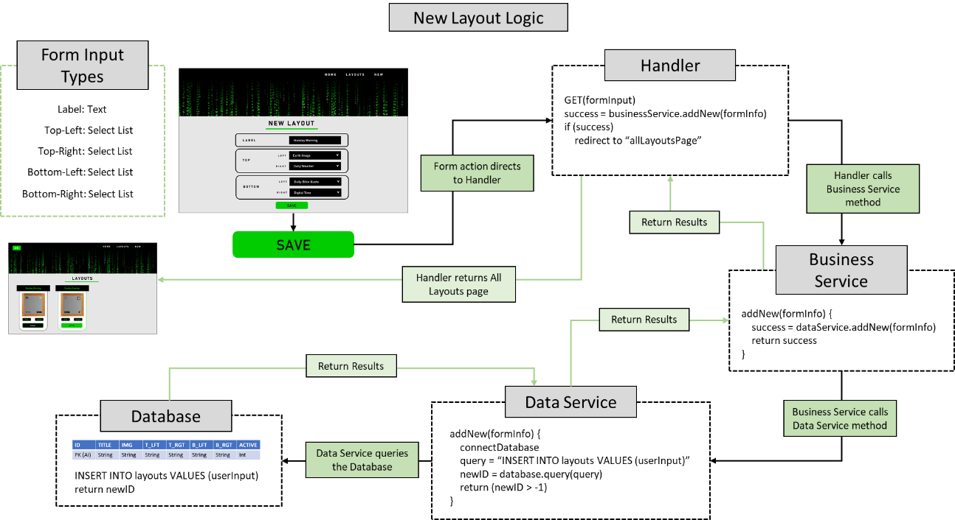

*A more detailed look into the logical design behind creating a new layout.*

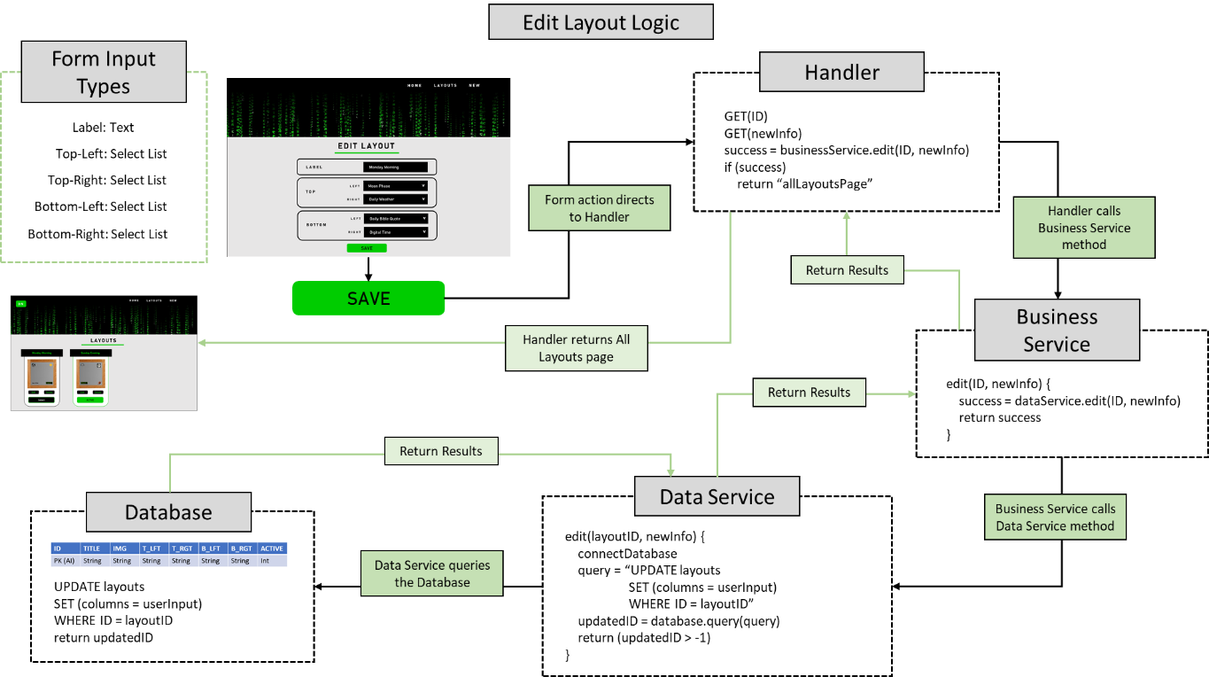

*A more detailed look into the logical design behind editing a layout.*

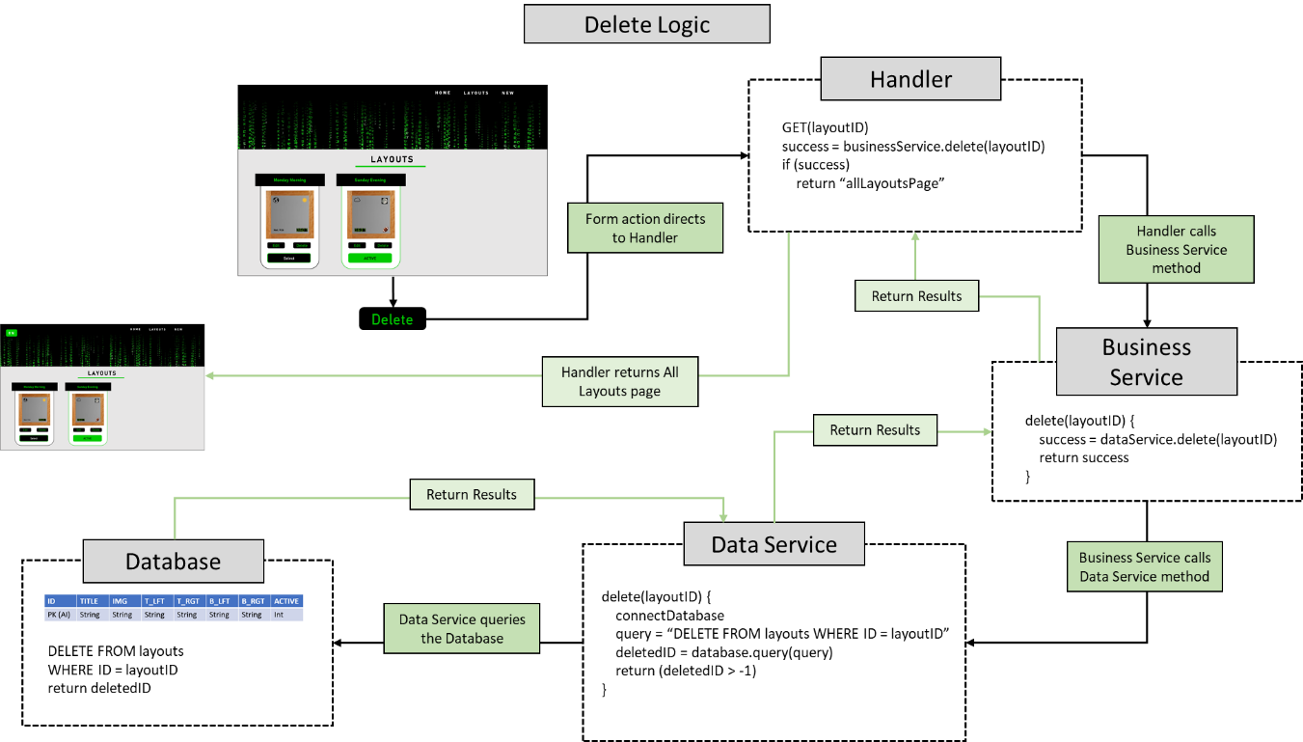

*A more detailed look into the logical design behind deleting a layout.*

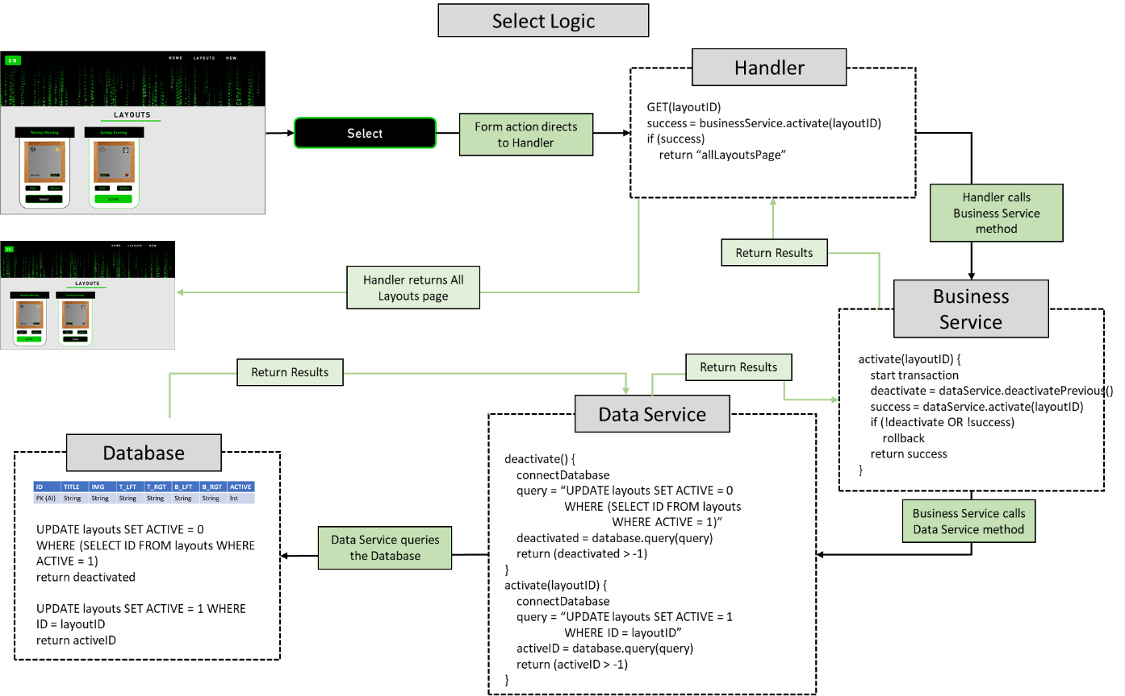

*A more detailed look into the logical design behind selecting a layout.*

Appendix A – Technical Issue and Risk Log

1. Use the template to identify and monitor project issues and risks.

|  |  |  |  |  |  |  |  |  |
| --- | --- | --- | --- | --- | --- | --- | --- | --- |
| Issues and Risk Log | | | | | | | | |
| **Issue or Risk** | **Description** | **Project Impact** | **Action Plan/Resolution** | **Owner** | **Importance** | **Date Entered** | **Date to Review** | **Date Resolved** |
| R | The current developers have never developed an application using Linux, and the command prompt may be difficult to learn. | This risk would impact the schedule but should not impact the scope or cost of the project. | The developers would need to become more familiar with Linux systems. | Project Manager | Low | 11/21/2021 | 11/28/2021 |  |
| R | The Raspberry Pi may become overheated and fail, so all data should be backed up on an external device. | If this risk became an issue, the schedule and cost would be greatly impacted. New hardware would need to be obtained, and backed up software would have to be transferred. | All program files will be stored on an external device so progress in the project is not lost through this issue. | CEO | Low | 11/21/2021 | 11/28/2021 |  |
| R | If the device is connected to the internet, the database and web server may be exposed and potentially compromised. | This would have a major impact on the project, as all devices on the network would become exposed and potentially damaged. | Only connect the Pi to the password protected Local Area Network (LAN). | Network Administrator | High | 11/21/2021 | 11/28/2021 |  |

Appendix B – References

Clarke, J. (2021, March 19). *JCLARKE0000/MMM-myscoreboard*. GitHub. Retrieved September 26, 2021, from https://github.com/jclarke0000/MMM-MyScoreboard.

Fewieden. (2020, April 28). *Fewieden/MMM-AlarmClock*. GitHub. Retrieved September 26, 2021, from https://github.com/fewieden/MMM-AlarmClock.

Garza, A. (2020, April 14). *Arthurgarzajr/MMM-dailybibleverse*. GitHub. Retrieved September 26, 2021, from https://github.com/arthurgarzajr/MMM-DailyBibleVerse.

Kingdon, N. (2020, November 5). *Nolankingdon/MMM-moonphase*. GitHub. Retrieved September 26, 2021, from https://github.com/NolanKingdon/MMM-MoonPhase.

LukeSkywalker92. (2021, January 17). *Lukeskywalker92/MMM-globe*. GitHub. Retrieved September 26, 2021, from https://github.com/LukeSkywalker92/MMM-Globe.

Mykle. (2020, August 17). *Mykle1/MMM-Insults*. GitHub. Retrieved September 26, 2021, from https://github.com/mykle1/MMM-Insults.

Teeuw, M. (2021, July 1). *Michmich/MagicMirror*. GitHub. Retrieved September 26, 2021, from https://github.com/MichMich/MagicMirror#manual-installation.

Teeuw, M. (2021, September 21). *3rd party modules · Michmich/MagicMirror Wiki*. GitHub. Retrieved September 26, 2021, from https://github.com/MichMich/MagicMirror/wiki/3rd-Party-Modules.

Appendix C – External Resources

|  |  |
| --- | --- |
| **GIT URL:** | [*https://github.com/KMorris63/SeniorProject1.git*](https://github.com/KMorris63/SeniorProject1.git) |
| **Hosting URL:** | <http://192.168.1.8/SeniorProject1/Mirror1/presentation/views/home.php> |